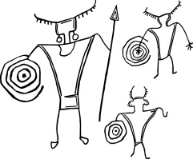
Utah Rock Art Research Association

P.O. Box 511324 Salt Lake City, UT 84151-1324 www.utahrockart.org

April 26, 2016
BLM Price Field Office
Attention: Amber Koski
125 S. 600 W.
Price, UT 84501
Dear Amber:
It is more than a little depressing that after years of discussing the development of a SRMA for Nine Mile Canyon that the BLM’s response is the following:
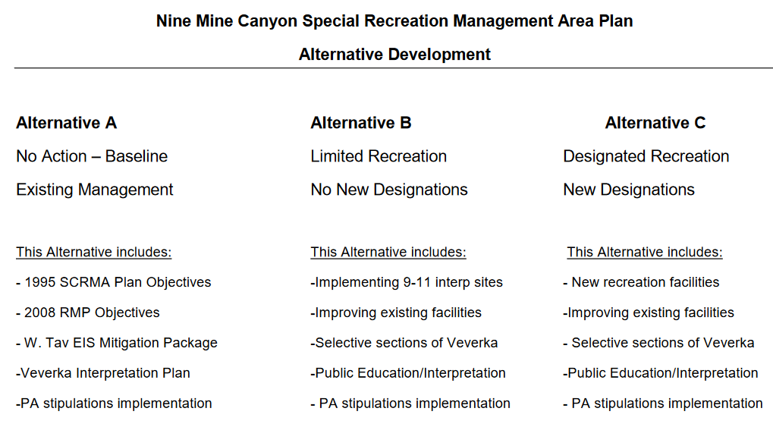
If this minimalistic one page document is all that was needed to go out to the public for comment why wasn’t it done six years ago after completion of the West Tavaputs Programmatic Agreement?
The Utah Rock Art Research Association (URARA) supports Alternative C.
The Carbon County Tourism Office indicates that Nine Mile Canyon is the most requested area in the county for tourism information and that there has been a great increase in visitation since the road has been paved.
Nine Mile Canyon is already a well-known tourism location. There are multiple books and brochures describing and locating the important sites within the canyon. URARA believes that implementing the Site Interpretation and Stewardship section of the West Tavaputs Programmatic Agreement which identifies seven areas for development and suggests that three to five additional unspecified sites also be developed must be completed. Tourists coming to the canyon are interested in cultural and historical sites and related information. This needs to be provided to them.
The Veverka Interpretation Plan provides a good starting point. But much has changed since it was developed in 2000. Technology allows for new ways of communication to visitors, the broad availability of GPS allows for precise site locations, the paved road requires new solutions to parking and visitor safety, and canyon ownership has been consolidated largely in the hands of EnerVest Corporation which may be an advantage if the company is willing to participate. For these reasons, we believe that new facilities and options for tourism are necessary. Improvement of existing facilities is insufficient. A more modern interpretation plan, based on the work started with Veverka needs to be created.
URARA supports creating trails, parking areas, signage and “rustic” campsites that would not directly compete with the more developed camping available at the Nine Mile Canyon Ranch. URARA is concerned about the Alternative C suggestion of designating new roads in the area. We do not believe this is necessary.
However, URARA notes that the Price Field Office has been unable, or unwilling, to execute its historical commitments:
- Its own 1995 SRMA.
- The 2000 Veverka plan which was developed by the Nine Mile Canyon Coalition and given to the BLM.
- The 2010 Site Interpretation and Stewardship section of the West Tavaputs Programmatic Agreement which provides third party funding to the BLM.
All of the above are components of each of the current SRMA alternatives. Given these facts, we wonder whether public opinion on the three options in the current SRMA are even relevant. Perhaps the more important questions are:
- Why does the Price Field Office believe the future will be any different from the past?
- Which of these three options does the Price Field Office believe it has the interest and resources to implement?
URARA is excited to be involved in the development of a SRMA that is implemented for Nine Mile Canyon. We believe that this process is much more dependent on the will and resources of the BLM rather than the concerns of the public. We urge the BLM to be thoughtful about their commitments.
Troy Scotter
Conservation and Preservation Committee

Communication with the Carbon County Office of Tourism, April 20/21, 2016.

