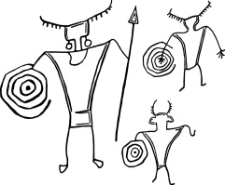
Utah Rock Art Research Association

P.O. Box 511324 Salt Lake City, UT 84151-1324 www.utahrockart.org

April 13, 2016

Bureau of Land Management
Attention: Jenna Whitlock, Acting State Director
PO Box 45155
Salt Lake City, UT 84154
Dear Ms. Whitlock:
The Utah Rock Art Research Association (URARA) would like to express support for the Western San Rafael Master Leasing Plan (MLP) as proposed by the Southern Utah Wilderness Alliance (SUWA). URARA has been an active partner in this area with the BLM. We have documented rock art sites , commented on leasing plans, commented on the Resource Management Plans (RMPs), and are participating as consulting parties in the Class I inventories underway in the Price and Richfield Field Offices.
We believe the extensive cultural resources found within the proposed MLP boundaries deserve more careful consideration and planning than were implemented in the RMPs for these areas. The RMP process of 2007 and 2008 was overwhelming for groups like ours who tried to respond to the thousands of pages of information from multiple field offices at the same time.
The BLM MLP process is an excellent way to address these shortcomings through a more thorough multi-disciplinary process. It also allows us to provide you with additional data which was unavailable at the time of the RMPs and gives the public an opportunity to provide feedback specific to this area.
We appreciate your consideration of the MLP.
Sincerely,
Troy Scotter
Conservation and Preservation Committee
Cc: Ahmed Mohsen: Price Field Office Manager
Wayne Wetzel: Richfield Field Office Manager

